Kenwood TH-79E

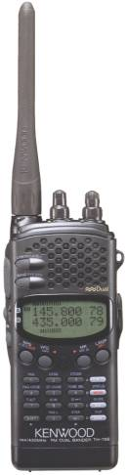

Type: Amateur VHF/UHF transceiver
Frequency range: 144-146 / 430-440 MHz
Mode: FM
RF Power output: Hi: 1.5-5 / 1.5-5 W (depending on voltage)
Lo: 0.5 / 0.5 W
El: 30 / 30 mW
Voltage: 5.5-16 VDC
Current drain: Rx: Max 80 mA TX: Max 1.8 A
Impedance: 50 ohms, BNC
Dimensions (W*H*D): 56*129.5*24.5 mm (with PB-32)
Weight: 320 gr (with PB-32, antenna, handstrap and belt hook)
Manufactured: 1994-199x (Discontinued)
Other: 80 memories. Twin RX

